Lab 10

Task: 1

Take a number as parameter and returns its factorial.

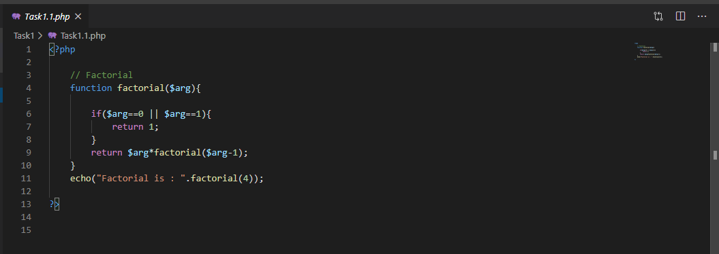

Output:

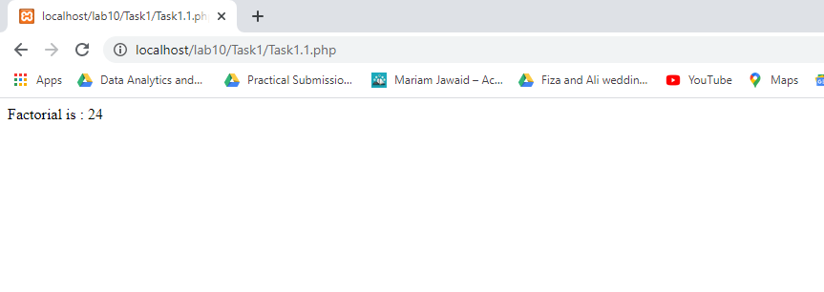Task:2

Create arithmetic functions with two and three variables as arguments using **function overloading** that returns addition, subtraction, multiplication and division of two or three numbers supplied as arguments.

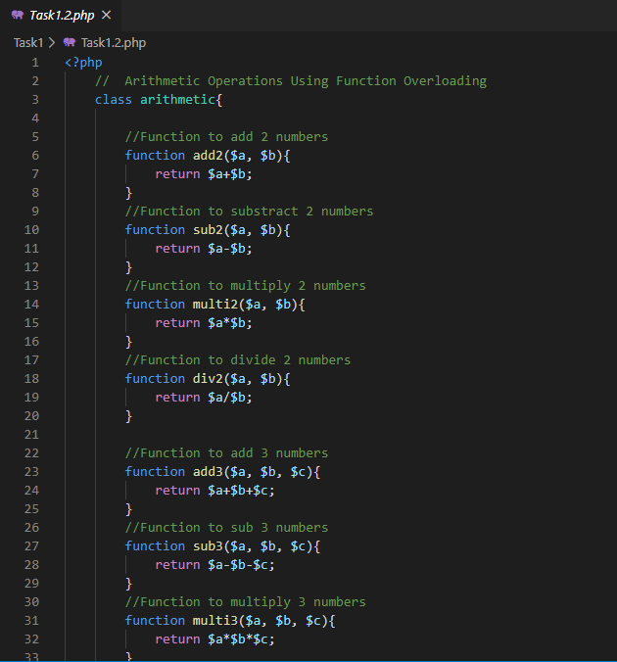

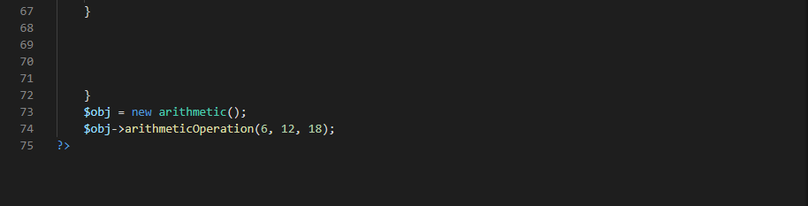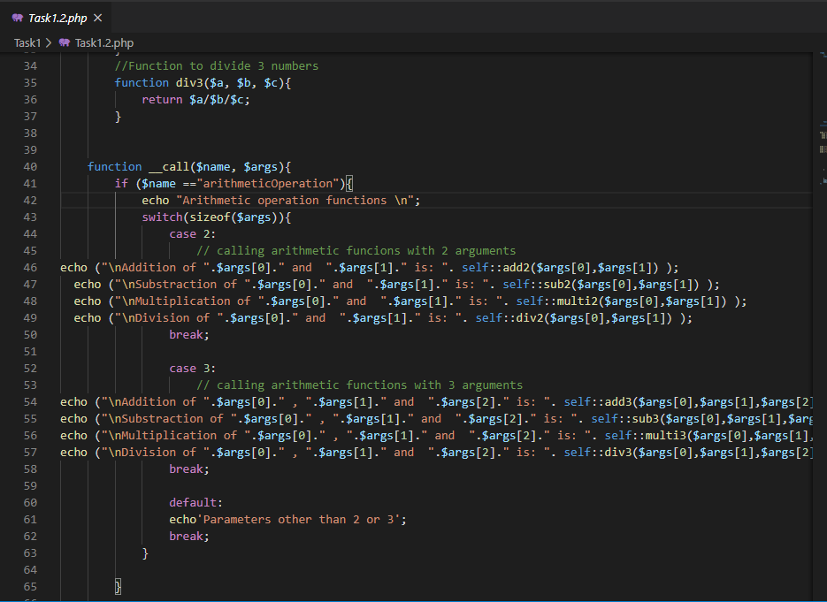Output:

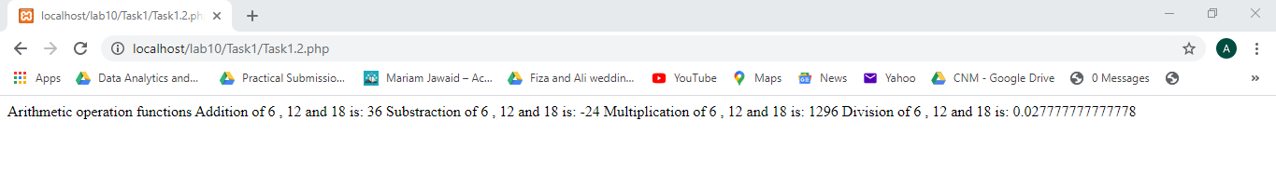

Task:3 Are there any other alternatives apart from the **default argument** hack to implement **function overloading**  in PHP? Explain each with an example.

Yes we can implement function overloading in PHP in two or more ways, other than default aurguments.

1. _call magical function
2. Fun get_args( ) method

Example 1

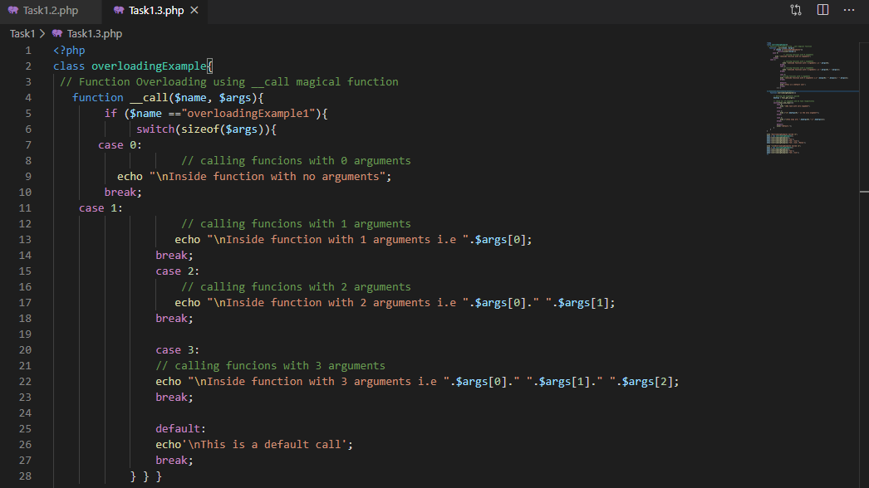

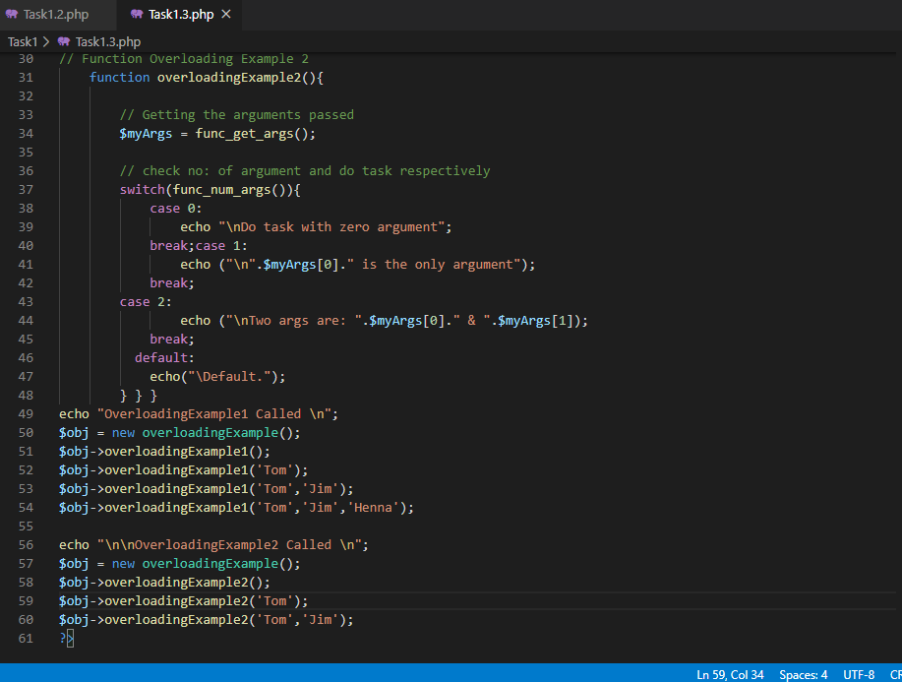Example 2

Output:

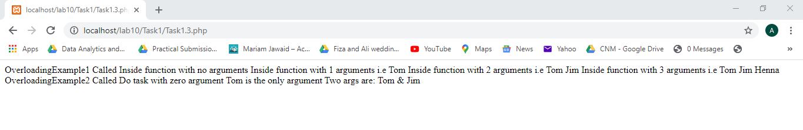

Task 4

Create an e-mail validator that takes **email** via HTML form from the user and then validates it on the server using the following conditions:

* + Should contain only one ‘@’
  + Does not start with a number
  + Should not contain spaces
  + Length should not be greater than 20
  + Should only end with .com or .edu.pk or .co.uk

Html file:

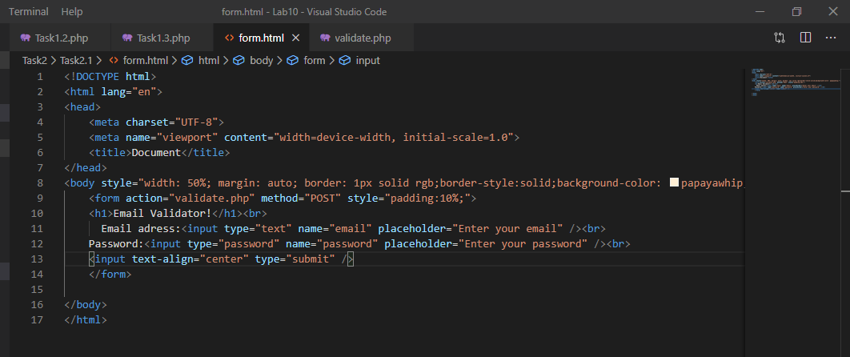

Php file:

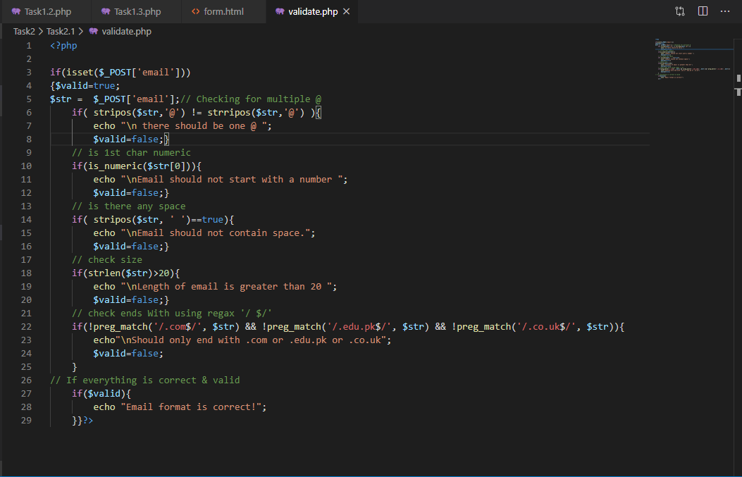

Output:



Error:



* Files with **JPG, PNG, PDF** extensions only and with a size less than or equal to 2 MB. Display a message when the file has been uploaded successfully.

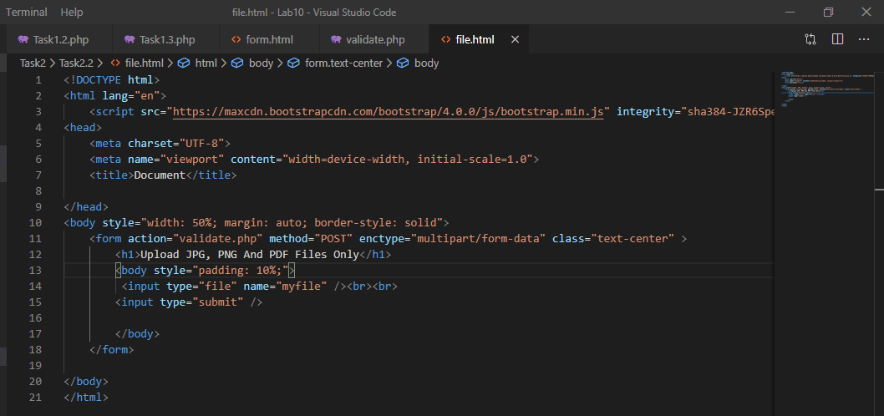

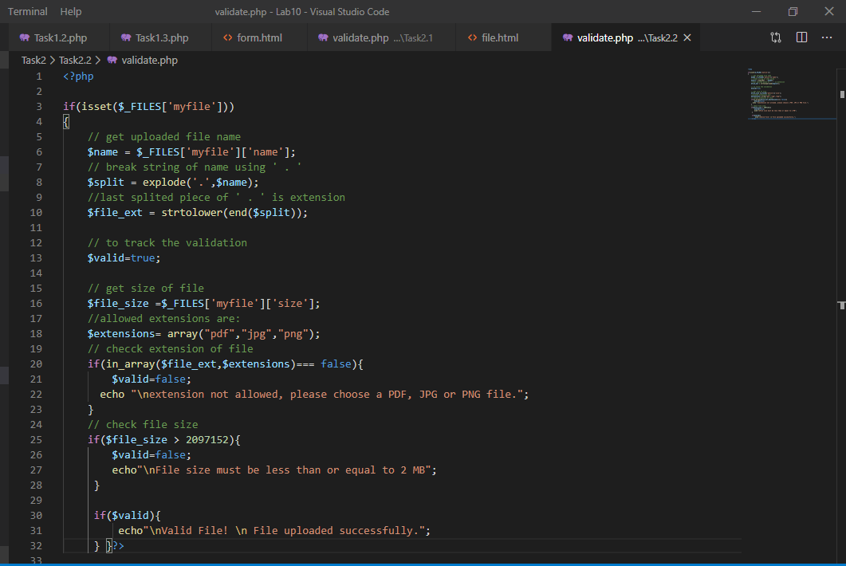

Output:



* A text file to the PHP server. Create HTML form controls for reading, writing, copying, renaming and deleting the uploaded text file.

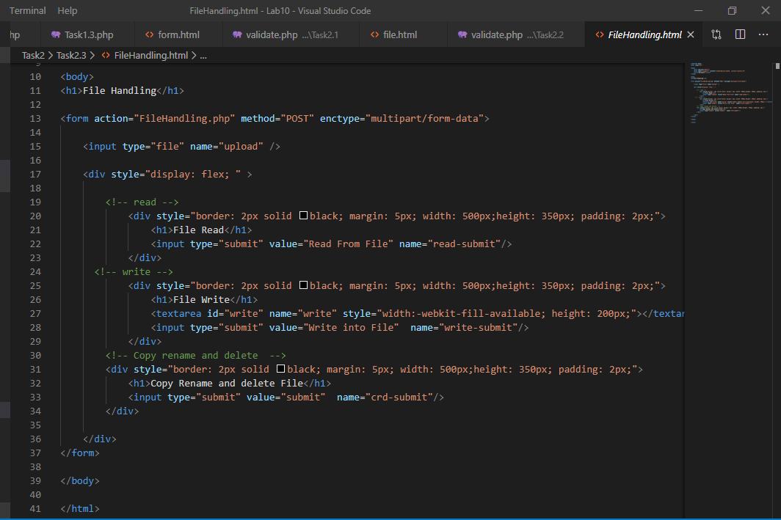

Php file

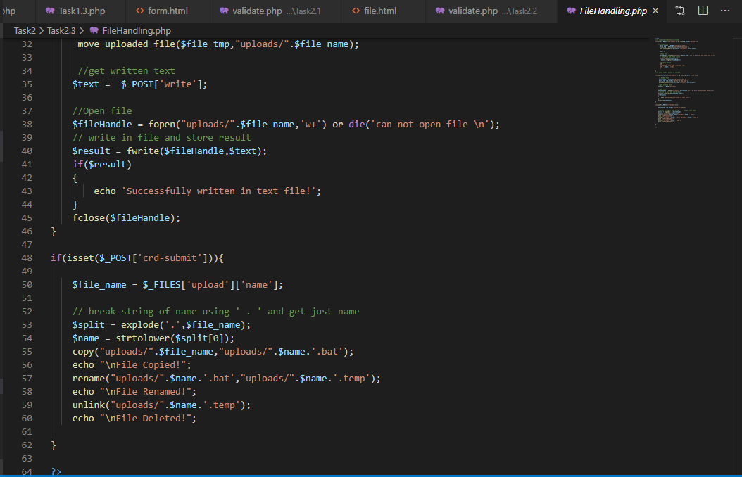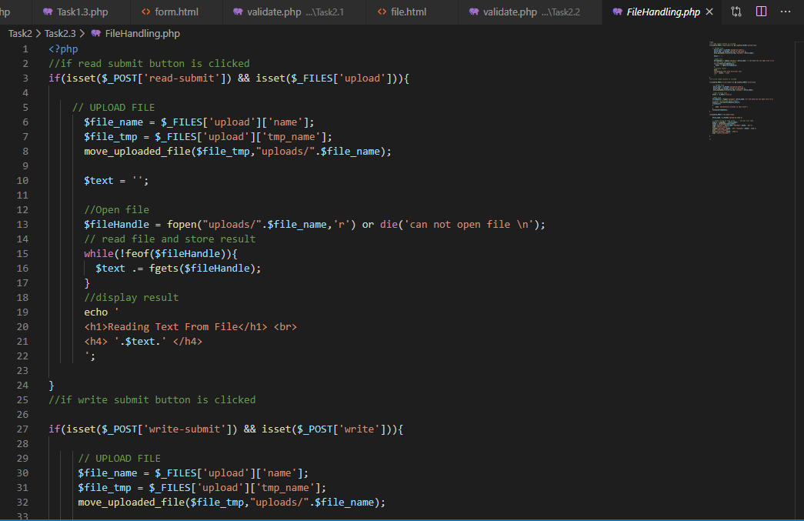

Output:

